


PJT03030.R5.PrePay.FS.CRM_Enrollment | 

REVIEWER(S)
Name | Title |  | Department |  | Reviewed (date/time)
Manoj Ajgaonkar |  | SAP QA Advisor |  | SE Project Team |  | <Date / Time>
Chaitanya Kodela |  | Solution Architect |  | SE Project Team - CE |  | <Date / Time>
Sadheesh Devadoss |  | Test Lead |  | SE Project Team |  | <Date / Time>
Jessica Scott |  | Consultant |  | Deloitte Controls |  | <Date / Time>
Jared Gilstrap |  | Consultant |  | PayGo |  | <Date / Time>
Ted Vann |  | Consultant |  | PayGo |  | <Date / Time>
Jack Hobbick |  | Smart Energy Testing |  | SE Core / Testing |  | <Date / Time>
Abhishek Bansal |  | Solution Architect |  | SE Project Team |  | <Date / Time>
Nilabja Guha |  | Systems Integration Lead |  | SE Project Team |  | <Date / Time>
John Lalicker |  | Consultant | Application Services |  | SE Project Team |  | <Date / Time>
Andy Wcisel |  | IT Tech Analyst |  | Cyber Security |  | <Date / Time>
Elizabeth Walgram |  | Business Readiness |  | CapGemini |  | <Date / Time>
Lisa Compton |  | Business Support Consultant |  | Digitial Customer Experience |  | <Date / Time>
Glenn MacRill |  | Integration Manager |  | SE Project Team |  | <Date / Time>

APPROVER(S)
Name | Title |  | Department |  | Approval (date/time)
Carrie Harkness |  | Business Owner |  | Energy Efficiency |  | E-Mail.Approvals
Zach Pakkala |  | Business Support Consultant |  | Customer Operations / SE Core |  | E-Mail.Approvals
Nancy Pierce |  | Business Support Consultant |  | Virtual Contact Center (VCC) - PMCCS |  | E-Mail.Approvals
Krishna Karunakaram |  | Manager, Release 5 (CE IT) |  | SE Project Team |  | E-Mail.Approvals
Blair Estep |  | Manager, Release 5 (HCL) |  | SE Project Team |  | E-Mail.Approvals
Tom Spring |  | Technical Team Lead |  | IT-C&APS |  | E-Mail.Approvals
Jeff Yankley |  | IT Portfolio Manager |  | IT-C&APS-IT App Portfolio-Front Office |  | E-Mail.Approvals
Linda Grimm |  |  |  |  |  | E-Mail.Approvals
Carrie Baker |  |  |  |  |  | E-Mail.Approvals
Ramesh Swarna |  | SAP Development Lead |  | SE Project Team |  | E-Mail.Approvals
Camie Wrozek |  | Business Support Consultant |  | Treasury-Finance & Admin |  | E-Mail.Approvals
Corey Nykamp |  | IT Portfolio Manager |  | IT-C&APS-IT App Portfolio-Back Office |  | E-Mail.Approvals

CONTRIBUTORS
Name | Organization | Area of Contribution
Corey Ritts | SAP | Author
Ryan Walker | Consumers Energy | Author

VERSION HISTORY
Version | Date | Author(s) | Revision Notes
0.1 | 09/15/2015 | Corey Ritts/Ryan Walker | Initial version
1.0 | 11/18/2015 | Ed Abranovich | Approved Baseline Work Product

Table of Contents

REVIEWER(S) 2
APPROVER(S) 2
1 OBJECT REQUIREMENT SUMMARY 4
1.1 Object Information and Attributes 4
1.2 Requirements Summary and Business Driver 5
1.3 Assumptions 5
1.4 Current Functionality 5
1.5 Required Functionality 5
1.6 Project / Development Constraints 5
1.7 Performance Criteria 5
1.8 Other Objects Affected 5
1.9 External References 5
1.10 Definitions/Acronyms/Abbreviations 6
2 ENHANCEMENT DESIGN SPECIFICATIONS 7
2.1 Detail Requirements - Enhancement 7
2.2 Custom Class 7
2.3 Standard Rule 7
2.4 Custom Table Creation 7
2.5 Work Item Delivery Requirements 7
2.6 Triggering Events Determination 7
2.7 Escalation Requirements 7
2.8 Dependencies 7
2.9 Error Handling Method 7
2.10 Post Execution Notification Details 8
2.11 Process Log Details 8
2.12 Other 8
2.13 Unit Test Plan 8
2.14 Information Security 8
2.15 Audit 9
2.16 Questions / Issues / Risks 9

OBJECT REQUIREMENT SUMMARY

Object Information and Attributes

The following is current information about this object and document:

Object ID | CRM_ENH_PP_01
Title | PJT03030.R5.PrePay.FS.CRM_ENH_PP_01
Team Which Owns the Object | PrePay SAP Team
System Version | CRM 7.0
Development Type | Enhancement
Priority | High
Estimated Complexity | Medium
Link to Process Flow | Refer to System BPD for PrePay Customer Enrollment:  http://teams/sites/PMO%20Team/SGE/SGE%20Documents/Forms/AllItems.aspx?RootFolder=%2Fsites%2FPMO%20Team%2FSGE%2FSGE%20Documents%2FRelease%205%20DLA%2DDPP%2F08%20Work%20In%20Progress%2FDefine%2FSystem%20Business%20Process%20Design%2FPrepay&InitialTabId=Ribbon%2EDocument&VisibilityContext=WSSTabPersistence

Requirements Summary and Business Driver

The PrePay program is being designed to provide the customer with the option to pay in advance for the energy they intend to consume. The benefits are founded on the premise that customers will have more control over energy bills and consumption. PrePay provides customers “real time” or “up-to-date” metrics on their energy usage, and balances, allowing customers to pay at their convenience.

Enrollment/De-Enrollment Screen – The screen will display and allow the CSR to enroll/de-enroll a customer. The screen will show eligibility, PayGo link, and enroll/de-enroll button. Enrollment Center Option - the enrollment center will be a universal enrollment area for Smart Energy Programs. The enrollment center will have links to SE programs and if the CSR clicks the PrePay link it will bring them to the enrollment screen.

Eligibility Check - In order to ensure that customers are eligible for PrePay Enrollment, a new ruleset for eligibility rules will be built in BRF+ (similar to the existing DPP and DLA Eligibility checks designed in BRF+). This new set of eligibility rules will be called when the CSR initiates the PrePayment screen. Enrollment Center Option – Upon selecting the enrollment center the eligibility check will be ran for all programs. Once ran the check will alert the CSR to what programs the customer is eligible for.

Scripting – Once the CSR clicks the enroll button, Terms and Conditions page will be displayed. The CSR will need to read the scripting to the customer and will require their agreement. Based on the customer’s agreement to the terms and conditions the customer will be able to enroll or de-enroll in the PrePayment program.

Contact Data - Data is required from the customer to be able to enroll in PrePay. Enrollment email is required to send the enrollment confirmation to the customer. The customer will also have to provide a preferred email, text, or phone and a critical email, text or phone to receive their notifications.

Enrollment - Once the eligibility is met, and the enroll button is selected, an exisiting customer will have a new contract and contract account created upon a new move-in completed. If it’s a new customer, without an invoice, the customer will use the newly created contract.

De-Enrollment - A customer can de-enroll from the program upon request or from a move-out. If the customer calls in for a De-enrollment the customer will be returned to a post pay customer but no change in contract account is needed. If a customer moves-out then the CSR will follow the normal move-out procedure.

CSR Alert - The CE CSR’s need to be alerted to the customer’s participation in the PrePay program. This will be displayed as an alert for the various stages of enrollment. When enrollment is initiated it will display “PrePay Enrollment Pending,” once the PrePay enrollment is completed and confirmed by PayGo the alert will display “PrePay Program Participant.” Upon De-enrollment from the program the alert will be removed.

Interaction Records - If customers call into the Consumers Energy call center and ask questions related to their PrePay participation and its impacts, the CE CSRs need to have a basic understanding of the customer’s participation in PrePay. To enable the CSRs, Interaction Records will be logged into system at various touchpoints, including enrollment and de-enrollment.
Summary Screen – The summary screen needs to be displayed to the CSR as a pop up after move in is completed. This summary screen will include the newly created contract account. This will allow the CSR to inform the customer of their new account number.

PayGo Link - Once the customer is enrolled into PrePay the CSR will need to have the ability to look at their account in realtime. This will be achieved through the PayGo website, which will hold the current balance remaining on their account. The CSR will be able to select the PayGo link in CRM to open the PayGo Portal.

Ref. | PRICEFW ID | Enhancement Description
 | CS_ENH_PPM_01 | CRM PrePay Enrollment/De-enollment Screen. (Includes Enroll/De-enroll button, Enrollment status, Reasons why enrollment is not possible, Contact fields, Scripting, Override, Pay Go Links, LBAR, Welcome packet, and Prepay enrollment in navigation bar)  Interaction Record and Contact creation during enrollment/ De Enrollment
Enrollment | PREP-011 | PrePay option will be offered during a move-in if the customers meet the eligibility criteria.
Enrollment | PREP-013 | PrePay Enrollment will be accomplished using CE CSRs.
Enrollment | PREP-022 | There will be a flag that drives account identifiers in CRM on LBAR alert that identifies PrePay Customers.
Enrollment | PREP-029 | CSR will have ability to add customer to PrePay program.
Enrollment | PREP-054 | PrePay customers must supply 1 out of 3 of the following communication channels. Communication channel types may be the same as long as the end-point is different (2 different e-mail addresses, 2 different phone numbers, etc..):  -E-mail account  -Text Messaging Number  -Phone Number (voice enabled)  Customer will identify a preferred communication channel for all PrePay Notices  Customer must also identify a critical communication channel (which must be different than preferred) for 2 day, 1 day, $0 balance and disconnect notice.
De-Enrollment | PREP-077 | All De-enrolls from PrePay will be accomplished by CE.
Enrollment | PREP-078 | Upon the reversal of a move-out, a new enrollment to active PrePay System Customer account shall be performed by a CSR.
Enrollment | PREP-079 | CSR's will need scripting information for PrePay Enrollment in CRM system.
Enrollment | PREP-080 | CSR must collect and validate the communication channels (Phone, E-mail, Text) for customer to be enrolled in PrePay.

Alternatives to Object
CE CSRs will have to manually complete all the steps for the enrollment into the PrePay Program. They will also need to manually check for customer participation in the program.

Impact of Implementation
By implementing the proposed objects the CE CSRs will require minimal effort in enrolling/de-enrolling a customer into PrePay program. They will also achieve greater visability into the customer’s program participation.

Impact of No Implementation
Greater manual effort required to enroll/de-enroll a customer in PrePay program.

Assumptions
- Customer completed enrollment correctly communicated by PayGo
- CSR will have granted required access by PayGo to access their portal.
- Custom table ZTPGM_ENROLL will already be created.
  - for specific details about table ZTPGM_ENROLL, refer to PJT03030.R5.SAP.FS.DPP.Receive Enrollment Request from 3P.CS_INT_DPP_003 Functional Specification

Current Functionality

This is a new process.

Required Functionality

1.5.1. PrePay Navigation - Enrolling a customer into the PrePay program, the CSR will be able to select a PrePay option from the navigation bar. They will select the over arrow on the Payment Plans section and select PrePay. This will take them to the enrollment page. This is configuration step, Mock up below. Enrollment Center Option – the CSR will select the enrollment center tab. Once the tab is selected they will be directed to the enrollment center page. From there they will select the PrePay link and brough to the PrePay enrollment page.

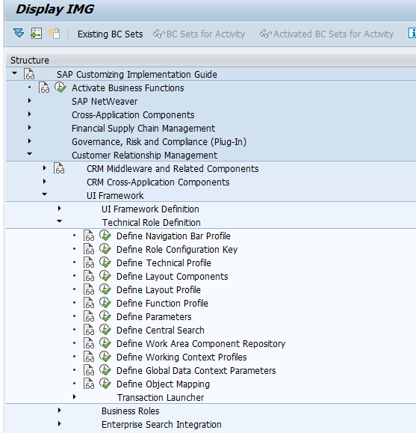

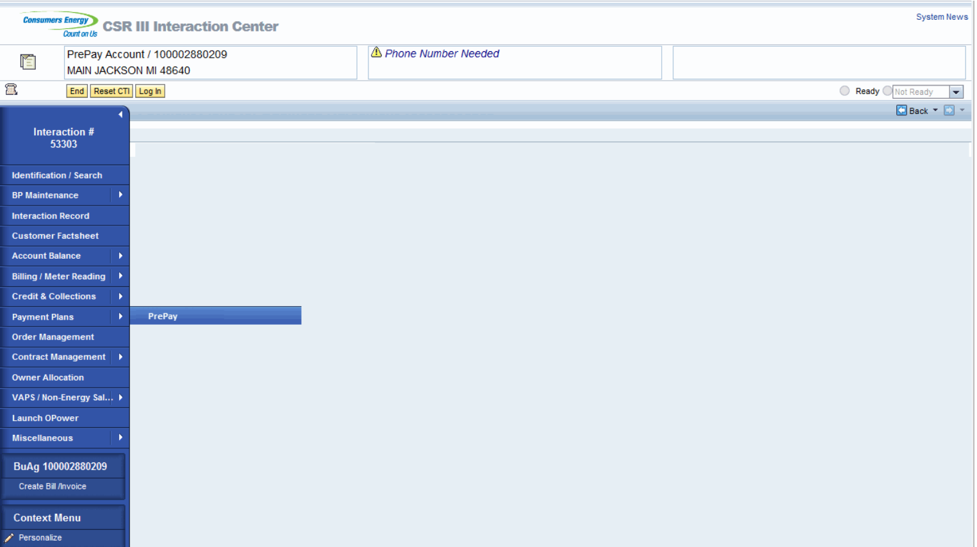

1.5.2. Eligibility Check - The eligibility check will run in the background, CRM will make a call to ECC BRF+ to perform the eligibility rules check. BRF+ will return the results to CRM for further processing. Any failure will be displayed to the CSR. The ineligible criteria will be referenced later in the document. Once the necessary steps are completed and eligibility is established the CSR will then be able to enroll the customer. Mock up below. Enrollment Center Option – When the CSR navigates to the enrollment center the eligibility check will be ran in the background. It will then display all the SE programs and show which ones the customer is eligible for. The eligibility check rules will act the same as if there was not an enrollment center and the calls will be the same. The only difference is where the trigger comes from.

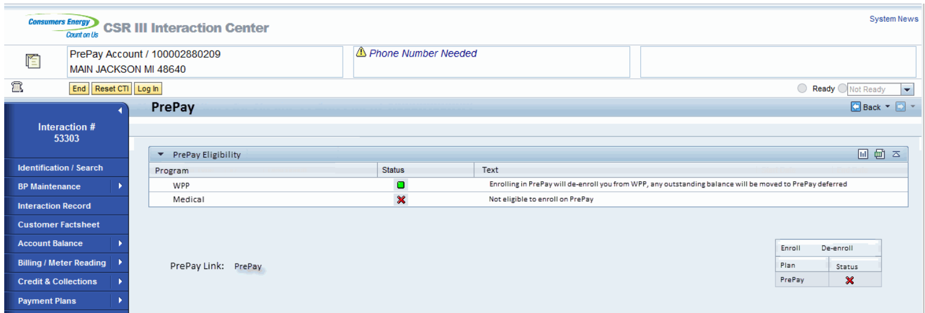

1.5.3. Terms and Conditions - The customer will have to accept the enrollment terms and conditions that will display once the enrollment button is clicked. Accepting the terms will continue the enrollment process by diaplaying the contact data popup. The customer will also have to accept a de-enrollment terms and conditions if they want to de-enroll from the PrePay program. Terms and Conditions mock up is below, wording will need to be provided by the business for enrollment and de-enrollment terms;

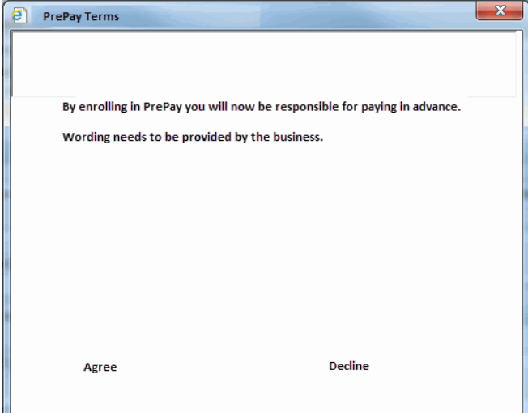

1.5.4. Contact Information – The customer will be required to submit/verify their contact information. PayGo requires an email to send out an enrollment confirmation message providing information to logging in, etc. They also will require preferred communication channels to the customer. No PrePay enrollment contact data will be used with the Ifactor preference center. PayGo will be sending all PrePay notification to the customer and will be maintaining the contact data. The contact information collected here is just for an initial contact and will just be used as a handoff to PayGo and maintained by PayGo. This can be email, voice, or text. Mock up below;

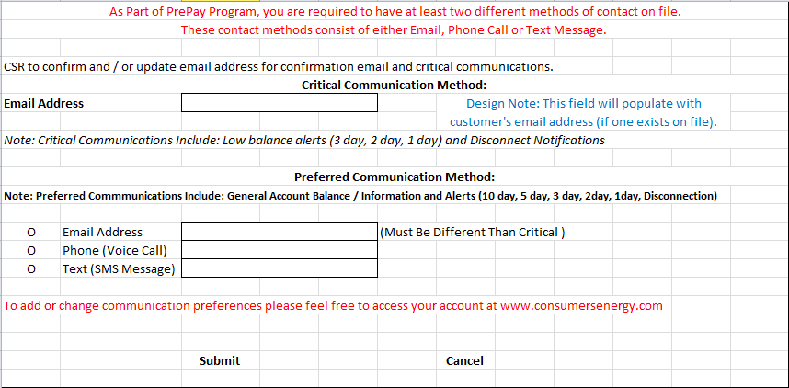

1.5.5. Enrollment - When the CSR submits the contact information enrollment will be kicked off as a background process. A custom event will need to be created to send the trigger and information to ECC. In ECC a move-in/out workflow will move out the existing customer’s current contract and move in the same customer with a new contract. If this is a new customer move in then CE will be using their newly created contract and contract account. The entire process will be referenced in Functional Spec name?

1.5.6. Summary Screen – Upon completion of the Move-In workflow, the customer will be assigned a new contract account. This contract account needs to be returned from ECC into CRM. The newly created contract account needs to be displayed on a summary screen for the CSR to relay to the customer. Mock up below.

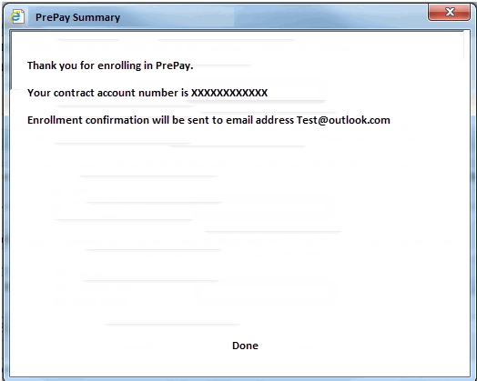

1.5.7. De-Enrollment – When a customer calls into de-enroll from PrePay and return to post pay, the CSR will select de-enroll from the prepay screen. The customer’s account will be changed back to post pay dunning and bill consolidators. There will need to be a custom event to send information and trigger to ECC. If the customer calls to move out it will be the same move-out process.

1.5.8. Interaction Records –
Enrollment Pending – Upon acceptance from a customer towards enrollment to the PrePay program an Interaction Record will be created in CRM. The attributes captured are:
  - SAP Business Partner
  - SAP Business Agreement (Contract Account Number)
  - Description: “Customer Programs PROGRAM NAME Enrollment Pending”
  - Categorization: Customer Programs –> PROGRAM NAME Enrollment Pending
  - Notes: “Contract <Contract Number>; Enrollment Pending from <Creation Date>; Caller Name <Caller Name>”

Enrollment Completed – Upon verification from the PayGo system that enrollment was successful on their end an Interaction Record will be created in CRM. The attributes captured are:
  - SAP Business Partner
  - SAP Business Agreement (Contract Account Number)
  - Description: “Customer Programs PROGRAM NAME Enrollment Completed”
  - Categorization: Customer Programs –> PROGRAM NAME Enrollment Completed
  - Notes: “Contract <Contract Number>; Enrollment Completed on <Completion Date>;”

De-enrollment Completed – Upon de-enrollment to the PrePay program an Interaction Record will be created in CRM. The attributes captured are:
  - SAP Business Partner
  - SAP Business Agreement (Contract Account Number)
  - Description: “Customer Programs PROGRAM NAME De-enrollment Completed”
  - Categorization: Customer Programs –> PROGRAM NAME De-enrollment Completed
  - Notes: “Contract <Contract Number>; De-enrollment on <Completion Date>;”

1.5.9. Alerts - Once the move in/out are completed an a alert will be created to notifiy the CSR that the PrePay enrollment is pending “PROGRAM NAME Enrollment Pending.”

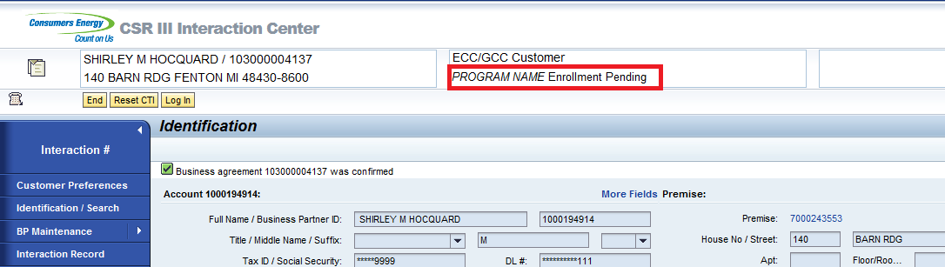

The alert will remain pending until a positive response is received from PayGo of their enrollment. When the PayGo response is received the status will be changed from Pending to Participant. “PROGRAM NAME Program Participant.”

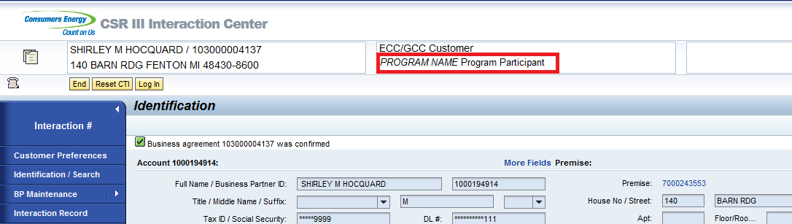

Upon De-enrollment from the program the alert needs to be removed and nothing will be displayed.

Project / Development Constraints
None Identified.

Performance Criteria

Other Objects Affected
None Identified.

External References

None Identified.

Definitions/Acronyms/Abbreviations

MPSC | Michigan Public service commission
SAP | Systems, Applications & Products in Data Processing
CE | Consumers Energy
DPP | Dynamic Peak Pricing
IEE | Itron Enterprise Edition

ENHANCEMENT DESIGN SPECIFICATIONS

Detail Requirements – Enhancement
2.1.1. Enrollment Screen

Enhancement Requirements
Number | Description of Requirement
1. | PrePay Eligibility Table – Table on PrePay view will displays which programs the customer is enrolled on. Table will include program, status and text. Eligibility requirements and logic will be handled in functional spec PJT03030.R5.PrePay.FS.ECC_ENH_PP_08
2 | PrePay Link – Once enrolled on PrePay the PrePay link will need to be enabled to allow the user to select the link and navigate the the PrePay portal. PrePay link requirements and logic will be handled in functional spec PJT03030.R5.PrePay.FS.CRM_ENH_PPM_07
3 | Enroll button – Needs to be enabled when eligible. When enroll button is selected it will display the terms and condition popup
4 | De-enroll button – Needs to be enabled when customer is enrolled. Selecting the de-enroll button will display terms and condition popup.



2.1.2. Eligibility Check

Enhancement Requirements
Number | Description of Requirement
1. | Use existing RFC enabled function module ZPGM_ELIGIBILITY_CHECK;  Populating the ECC Structure ZSENRL_INT_STRUC  The input fields for the structure  ZENRLDAT Types DATS 8 Enrollment Date  ZENRLTIM Types TIMS 6 Enrollment Time  ZENRLSDP Types CHAR 30 Enrollment Service Delivery Point ID  ZENRLBP Types CHAR 10 Enrollment Business Partner Number  ZENRLCA Types CHAR 12 Enrollment Contract Account Number  ZCALLERNAME Types CHAR 30 Caller Name  ZPGMTYPE Types CHAR 3 Interface Program Type  ZENRL_SOURCE Types CHAR 3 Enrollment Source  ZCONTRACT Types CHAR 10 Contract
2. | Once CE initiated (from CRM) by clicking PrePay submenu, call the RFC FM ZPGM_ELIGIBILITY_CHECK from CRM  CALL FUNCTION ‘ZPGM_ELIGIBILITY_CHECK’  EXPORTING  BU_PARTNER CHAR 10 = BP Number (Table BUT000)  sy-datum DATS 8 = Enrollment Date (System Date)  sy- TIMS 6 = Enrollment Time (System Time)  BU_NAMEP_L CHAR 40 = Last name of business partner (BUT000)  BU_NAMEP_F CHAR 40 = First name of business partner (BUT000)  CRM_ISU_CONTRACT CHAR 10 = Contract Number (CRMV_ISU_INDEX_I)  CRMT_BUAG_ID CHAR 12 = Business Agreement Number (CRMM_BUAG)  ZENRL_SOURCE CHAR 3 = Enrollment Source (CRM)  ZPGMTYPE CHAR 3 = Interface Program Type (PPY)  CRM_ISU_DEVLOC CHAR 30 = Device Location (Pull from BOL Relations)
3. | Reuse ECC BRF+ application PGMENRL_PRE_VALIDATION
4. | Eligibility requirements and logic will be handled in functional spec PJT03030.R5.PrePay.FS.ECC_ENH_PP_008

Eligibility check will be performed when the CSR clicks the PrePay sub menu tab from the navigation bar. A call will be triggered from the PrePay submenu using Function Module ZPGM_ELIGIBILITY_CHECK. BRF+ application PGMENRL_PRE_VALIDATION, PrePay Enrollment Eligibility rules (similar to how DLA and DPP are performing – see screenshot below) from CRM to ECC.

If the account does not pass all of the BRF+ eligibility rules for PrePay Enrollment, the error will be returned to CRM. This error or errors will all need to be displayed to the CSR on the enrollment screen. There will be hard stop errors and warning messages, mock up below. The CSR can enroll a customer on PrePay even with a warning message being displayed. However a customer will not be able to enroll if they have a hard stop error. The CSR will have the ability to see the error and how to correct it if the customer would like to enroll. Once the customer passes the eligibility check the Enroll button will need to be able to be selected, mock up below.

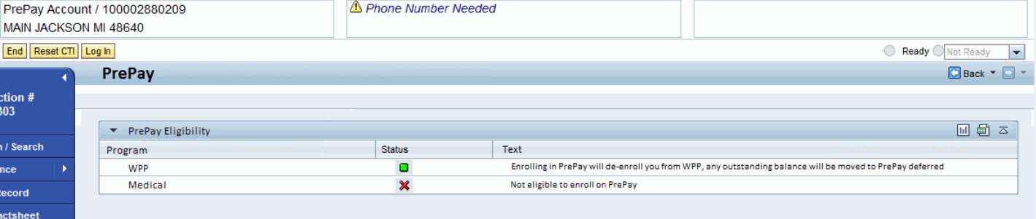

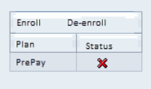
Once the eligibility is corrected and passed the status will change to green and the Enroll button will be able to be selected. Once selected the terms and conditions will need to be triggered.

2.1.2.6. Triggering Event
PrePay Submenu tab selected.

2.1.3. Terms and Conditions

Enhancement Requirements
Number | Description of Requirement
1. | Enrollment terms and conditions text will display when the user selects enroll from the PrePay view.
2 | Enrollment terms and conditions Agree button will display the contact data popup section 2.1.4.
3 | De-enroll terms and conditions text will display when the user selects de-enroll from the PrePay view.
4 | De-enroll terms and condtion, Agree button will trigger the de-enrollment in ECC.
5 | Once the Agree button is clicked, trigger custom event for de-enrollment using  Business object; ZISUACCNT  Event; zppmdeenroll
6 | List of parameters for custom event ZISUACCNT and zppmdeenroll  Parameters;  DeEnrollmentDate (default system date)  CreatedBy (default system user)

Terms and condition view


2.1.4. Contact Information

Enhancement Requirements
Number | Description of Requirement
1. | When user select Agree button from PrePay terms and conditions, contact data popup will display with contact data fields and text.
2 | Enrollment Confirmation email will prepopulate the email field if customer has an email on file. This email can be changes and is required to continue PrePay enrollment  C7P:  BP table But021_fs – Pull Address number AD_ADDRNUM  Address number table ADR6 – Pull email AD_SMTPADR
3 | Preferred Text and Voice fields will prepopulate when the voice or text radio button is selected. One field is required Text, Voice, Or Email to continue enrollment.  C7P:  BP table But021_fs – Pull Address number AD_ADDRNUM  Address number table ADCP – Pull Telephone AD_TLNMBR1
4 | If the Email radio button is selected it will need to be different than the critical email address. System will need to populate a message stating the preferred email needs to be changed.
5 | Submit button will trigger the enrollment in ECC.
6 | Cancel button will close the screen and no changes will occur in the system.
7 | Once the submit button is clicked, trigger custom event for enrollment using  Business object; ZISUACCNT  Event; zppmenroll
8 | List of parameters for custom event ZISUACCNT and zppmenroll  Parameters;  EnrollmentReqDate (default system date)  EMailAddress (take from contact screen)  PreferredCommMethod (take from contact screen)  PreferredCommChannel (take from contact screen)  CriticalCommMethod (take from contact screen)  CriticalCommChannel (take from contact screen)  CreatedBy (default system user)
9 | Using the below Function Module validate the email address format is valid.  lv_email_adr-type = 'INT'.  lv_email_adr-address = <but051>-smtp_address.  call function 'SX_INTERNET_ADDRESS_TO_NORMAL'  exporting  address_unstruct = lv_email_adr  exceptions  error_address_type = 1  error_address = 2  error_group_address = 3  others = 99.
10 | To validate the Phone Number format CHAR LENGTH = 10 or 12 (depending on Business rule)  l_c_allowed_chars TYPE char30 VALUE '0123456789-',  l_c_allowed_nums TYPE char30 VALUE '0123456789',

Contact Data View


2.1.5. Summary Screen

Enhancement Requirements
Number | Description of Requirement
1. | Once the submit button is selected from the contact details, the PrePay summary screen needs to be displayed
2 | The Summary screen needs to display the newly created contract account from ECC upon completion of the Move-In workflow.
3



2.1.6. Alerts

Enhancement Requirements
Number | Description of Requirement
1. | Create a Z-Class ZCL_CRM_IC_F_G_PPM: Use CL_CRM_IC_F_G_BA as Superclass.
2 | Implement Interface method IF_CRM_SMF_SERVICE~EXECUTE, to process/return the following ICRULE attributes:  - ZPPM_PENDING  - ZPPM_CANCELED  - ZPPM_COMPLETED  - ZPPM_DEENROLL
3 | ZPPM_PENDING is set to “X” if:  The confirmed account has an entry in the PrePay Enrollment table (ZTPGM_ENROLL) and the status is = to ‘Pending’.  The above check is performed for the confirmed BA, and will query the PrePay Enrollment Table as stated.
4 | ZPPM_CANCELED is set to “X” if:  The confirmed account has an entry in the PrePay Enrollment table (ZTPGM_ENROLL) and the status is = to ‘Canceled’.  The above check is performed for the confirmed BA, and will query the PrePay Enrollment Table as stated.
5 | ZPPM_COMPLETED is set to “X” if:  The confirmed account has an entry in the PrePay Enrollment table (ZTPGM_ENROLL) and the status is = to ‘Enrolled’.  The above check is performed for the confirmed BA, and will query the PrePay Enrollment Table as stated.
6 | ZPPM_DEENROLL is set to “X” if:  The confirmed account has an entry in the PrePay Enrollment table (ZTPGM_ENROLL) and the status is = to ‘De-Enrolled’.  The above check is performed for the confirmed BA, and will query the PrePay Enrollment Table as stated.
7 | The Alerts are triggered for the following IC Events: BuAgConfirmed. The event is defined within the Rule Policy ZPPM_ALERTS.

When PrePay Enrollment is completed in CRM successfully, an entry is created for the account in the PrePay Enrollment table (ZTPGM_ENROLL) with a status of Pending. The PrePay Enrollment Pending alert should be triggered if the account has an entry in the PrePay Enrollment table with a status of ‘Pending’. The alert will be initiated at the time the Business Agreement is confirmed in CRM.

- If the status is Pending then the alert is;
  - “PrePay Enrollment Pending”



When a positive enrollment response is received from the interface with PayGo, an entry will be made in the PrePay enrollment table (ZTPGM_ENROLL). Upon Business Agreement confirmation, the system should check table ZTPGM_ENROLL to identify if the account has an entry in the table. If the entry is in ‘Completed’ status it should display Program Participant alert.

- If the status is Completed then the alert is;
  - “PrePay Program Participant”



When a De-enrollment is completed in CRM a custom event (ZPPMDEENROLL) will be initiated to de-enroll the customer in ECC. An entry into the PrePay enrollment table (ZTPGM_ENROLL) will be created. Upon Business Agreement confirmation, the system should check table ZTPGM_ENROLL to identify if the account has an entry in the table. If the entry is in ‘De-Enrolled’ status it will not display any alert for PrePay.
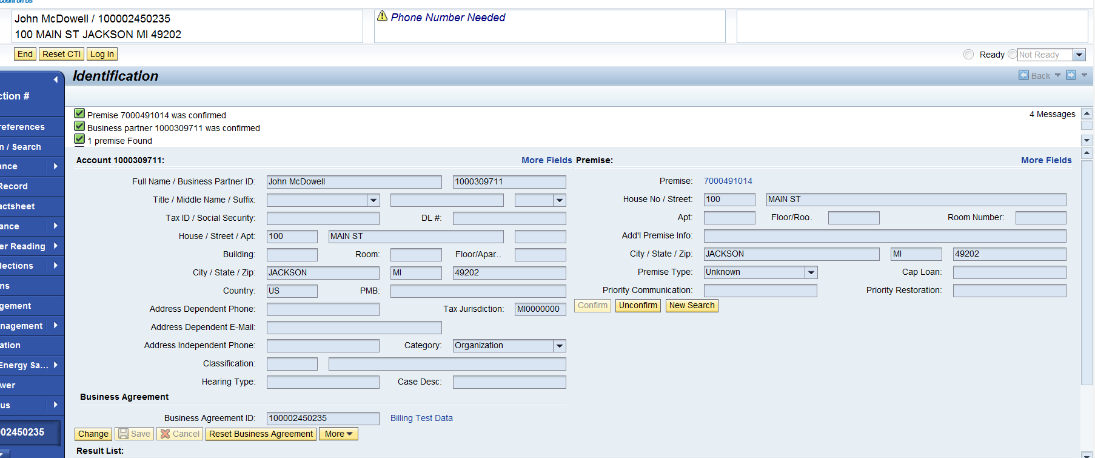

Creation of new class:
ZCL_CRM_IC_F_G_PPM

Creation of new ICRULE attributes:
ZPPM_PENDING
ZPPM_COMPLETED
ZPPM_CANCELED
ZPPM_DEENROLLED

The Alerts are triggered for the following IC Events: BuAgConfirmed. The event is defined within the Rule Policy ZPPM_ALERTS.

2.1.6.2. Custom Class
ZCL_CRM_IC_F_G_PPM

2.1.6.6. Triggering Event
BUAGConfirmed.

2.1.6.8. Dependencies
In order for any of the PrePay Enrollment Alerts to work as expected, the Rule Policy and Alert must be configuration must be completed in CRM.

2.1.7. Interaction Records

Enhancement Requirements
Number | Description of Requirement
1. | Use existing RFC-enabled FM Z_SE_IR_CREATE which was created under FG Z_SMARTENERGY to create interaction records for PrePay as well.  This function module has below input parameters:  I_BP TYPE BU_PARTNER Business Partner ID  I_APP_ID TYPE CHAR20 Application ID  I_TEXT TYPE STRING Long Text  I_BUAG TYPE CHAR12 Business Agreement ID  Within this function module an existing method zcl_ir_utility=>z_ir_bp_update is used to create interaction record for the BP. And then BAPI_REL_CREATERELATION is used to create relations between BP and business agreement. Exception handling is also done.
2 | Once CE initiated (from CRM) enrollments make to PrePay Enrollment staging table in CE SAP ECC system, call the RFC FM Z_SE_IR_CREATE in CRM and to create Enrollment pending interaction record  CALL FUNCTION 'Z_SE_IR_CREATE'  EXPORTING  i_bp = <BP Number>  i_app_id = “SE_PPM_ENRL_PND”  i_text = “Contract <Contract Number>; PrePay Enrollment Pending from <Creation Date>; Caller Name <Caller Name>”  i_buag = <BUAG Number>  IMPORTING  ir_created = ir_created<Boolean field true/false>  ir_number = ir_number<interaction record number>  EXCEPTIONS  ir_not_created = 1  no_bp_passed = 2  no_business_agreemen t = 4  no_confirmed_bp = 5  no_application_id = 6  bus_agr_rel_error = 7  bus_agr_set_notfound = 8  OTHERS = 9.
3 | Once the Enrollment is completed for the record in PrePay enrollment staging table call the RFC FM Z_SE_IR_CREATE in CRM and to create Enrollment completed interaction record  CALL FUNCTION 'Z_SE_IR_CREATE'  EXPORTING  i_bp = <BP Number>  i_app_id = “SE_PPM_ENRL_CNF”  i_text = “Contract <Contract Number>; Enrollment Completed on <Completion Date>;”  i_buag = <BUAG Number>  IMPORTING  ir_created = ir_created<Boolean field true/false>  ir_number = ir_number<interaction record number>  EXCEPTIONS  ir_not_created = 1  no_bp_passed = 2  no_business_agreemen t = 4  no_confirmed_bp = 5  no_application_id = 6  bus_agr_rel_error = 7  bus_agr_set_notfound = 8  OTHERS = 9.
4 | Once De-Enrollment is completed for the record and PrePay enrollment staging table is updated with status de-enrolled for the customer and contract account combination then FM Z_SE_IR_CREATE is called to created interaction record.  CALL FUNCTION 'Z_SE_IR_CREATE'  EXPORTING  i_bp = <BP Number>  i_app_id = “SE_PPM_DNRL_CNF”  i_text = “Contract <Contract Number>; PrePay De-enrollment on <Completion Date>;”  i_buag = <BUAG Number>  IMPORTING  ir_created = ir_created<Boolean field true/false>  ir_number = ir_number<interaction record number>  EXCEPTIONS  ir_not_created = 1  no_bp_passed = 2  no_business_agreemen t = 4  no_confirmed_bp = 5  no_application_id = 6  bus_agr_rel_error = 7  bus_agr_set_notfound = 8  OTHERS = 9.
5 | Once Enrollment Canceled is completed for the record and PrePay enrollment staging table is updated with status Enrollment Canceled for the customer and contract account combination then FM Z_SE_IR_CREATE is called to created interaction record.  CALL FUNCTION 'Z_SE_IR_CREATE'  EXPORTING  i_bp = <BP Number>  i_app_id = “SE_PPM_ENCL_CNF”  i_text = “Contract <Contract Number>; PrePay Enrollment Canceled on <Completion Date>;”  i_buag = <BUAG Number>  IMPORTING  ir_created = ir_created<Boolean field true/false>  ir_number = ir_number<interaction record number>  EXCEPTIONS  ir_not_created = 1  no_bp_passed = 2  no_business_agreemen t = 4  no_confirmed_bp = 5  no_application_id = 6  bus_agr_rel_error = 7  bus_agr_set_notfound = 8  OTHERS = 9.

2.1.7.2. Custom Class
Reuse ZCL_IR_UTILITY

2.1.7.6. Triggering Event
CE Initiated Enrollment/De-enrollment, and Inbound PayGo confirmation of enrollment via interface

2.1.7.9. Error Handleing Method
Exceptions on the Z-class, to be reported back to the caller program in ECC.

2.1.7.11. Process Log Details
New Message IDs can be created under ZSG_CRM, and updated for each APP_ID, used for the “zcl_ir_utility=>z_ir_bp_update”, input variable “i_msg1”.

Unit Test Plan

The following scenarios need to be tested.

Unit test Step No | Test Condition | Expected Result | Actual Result
 | PrePay Navigation
1 | Navigate to the Payment Plan SubMenu | PrePay tab is displayed
2 | Select PrePay tab | PrePay Eligibility check is ran and results displayed on the enrollment page
 | Eligibility Check
3 | Run Eligibility check for ineligible customer | Ineligible reasons are displayed on the enrollment screen
4 | Correct the failed eligibilty reason(s) and navigate back to the PrePay enrollment screen to re-initiate eligibility check | Ineligible reasons are corrected and customer now passes eligibility check
 | Enrollment – Terms and Conditions
5 | Click enroll on the PrePay enrollment screen | The Terms and conditions page is displayed
6 | Decline the Terms and Conditions | The CSR is returned to the enrollment screen
7 | Accept the Terms and Conditions | The Contact information pop up is displayed
 | De-Enrollment – Terms and Conditions
8 | Click De-enroll on the PrePay enrollment screen | The Terms and Conditions page is displayed
9 | Decline the Terms and Conditions | The CSR is returned to the enrollment screen
10 | Accept the Terms and Conditions | The Customer is de-enrolled from the PrePay Program
 | Enrollment – Contact Information
11 | Accept the Terms and Conditions | Contact information pop up is displayed and autopopulates available fields from the BP (Email, Phone number)
12 | Select the Cancel field | Upon hitting Cancel the popup is closed and the CSR is returned to the PrePay Enrollment screen
13 | Enter the fields and click submit | The fields are accepted and the enrollment process is kicked off in ECC
 | Enrollment/De-enrollment - Alerts
14 | Account Confirmed in IC, when the Enrollment is in Pending status. | Alert “PROGRAM NAME Enrollment Pending” is displayed.
15 | Account Confirmed in IC, when the Enrollment is in Completed status. | Alert “PROGRAM NAME Program Participant” is displayed.
16 | Account Confirmed in IC, when the De-enrollment is Completed. | No Alert is displayed.
17 | Account Confirmed in IC, when the Enrollment is Canceled. | No Alert is displayed.
 | Enrollment/De-Enrollment – Interaction Records
18 | Enrollment started, awaiting PayGo confirmation | IR captured for PrePay Enrollment Pending.
19 | Enrollment completed | IR captured for PrePay Enrollment Completed.
20 | De-enrollment completed | IR captured for PrePay De-enrollment Completed.
21 | Enrollment Canceled completed | IR captured for PrePay Enrollment Canceled Completed.

Information Security

Information Classification

Security Roles (Profiles and Authorizations)
Below are the roles that need access to be able to enroll/De-enroll a customer. This will be a controlled through the screen navigation configuration.

Role Name | Role Description
ZIC_BKOF | Customer Billing Bus. Role (4)
ZIC_CSR1 | CSR I Business Role (1)
ZIC_CSR2 | CSR II Business Role (2)
ZIC_CSR3 | CSR III Business Role (3)
ZIC_CSRX | Outsource CSR Business Role-10
ZIC_VCC | VCC Mgmt Bus. Role (9)
ZIC_RVRC | Revenue Recovery Bus. Role (5)
ZCRM7_BRC | CSR III B. Role - BRC Switch
ZCRM7_PRM | CSR III B. Role - PRM Switch
ZIC_BCOP | Business Ctr Bus. Role (7)
ZIC_TRAINING | Training Dept Bus. Role (0)

Table Security (if applicable)

ABAP Program Security (if applicable)

Audit

Questions / Issues / Risks

